Parent Link

A time for... Bible reading: Ecclesiastes 3.
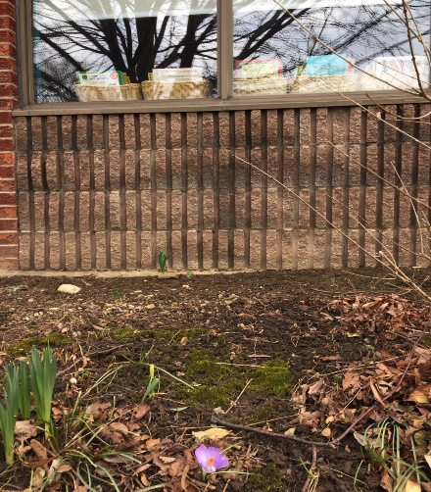
If you are like me, you sometimes hear yourself saying, “When this or that happens, then I will . . . or, If only so and so would do this, then …. " In longing for some future good or longing for the good old days (of teacher strikes and railroad blockades :) we sometimes forget that every day — regardless of the weather or our circumstances or pandemics or finances or mood or health — is a gift from God to be used for His glory. According to author Ron Ash, “We are where we need to be and learning what we need to learn. Stay the course because the things we experience today will lead us to where He needs us to be tomorrow.”
In every season, there is a reason to rejoice and an opportunity to do good (Eccl. 3:12). The challenge for each of us every day is to find something to rejoice about and some good to do—and then to do both. (adapted from OurDailyBread.org)

Blessings for your week, Mrs Verbeek.

Looking for spring: I was looking for signs of spring and look what I found (look at the very bottom of the photo)! Do you know where this is? Be specific - which window?

Monday: Eden Verkuyl- Gr. 7
Nicole Wolf- Gr. 3
Tuesday: Isaiah Pastoor- Gr. 4
Friday: Jocelyn Sikma- Gr. 3
Saturday: Miss Body- SK Teacher
Abby VanderHoek- Gr. 7

For your Information:
Welcome back from your extended March break! Can you believe that two short weeks ago, life was almost normal? We didn’t even know what physical distancing or self isolation were. In this strange and difficult time, our desire is for all of us to act out of love and concern for the wellbeing of our families, our neighbours, and the vulnerable and elderly in our communities. Love your neighbour! Really! See the poster titled: Social Distancing and the link to the pdf below with reminders for how to keep our communities as well as we can. Public health experts continue to tell us that we can make a difference by keeping our distance - so play dates, gathering at the park, or getting together for birthday parties are off the table. In a while they can happen again. I would love to hear how you are being creative in connecting with your favourite people and the people in need of visits or seeing a friendly face. How are you being a good neighbour? Tell us your stories! Virtual campfires? Remote visiting to play board games? (Thanks Melissa!) Send your ideas to office@woodstockchristian.ca.

Prayer Corner: We continue, even in uncertain times, to thank God for his overflowing blessings and love. Pray for all those who are under the weather with illness or who are anxious and worried. Congratulations to Emit and Aubrey and their family as they have a new baby sister at their home! If you have specific prayer requests, be sure to pass those along to our prayer team through j.mulder@woodstockchristian.ca. Please pray for our students and families and staff as we face new issues, establish new routines, and work through new challenges. Pray for our community and world.

Health tips: https://ministry-to-children.com/talking-to-kids-about-coronavirus/
https://lifespeak.com/how-to-manage-anxiety-during-the-coronavirus-outbreak/
https://www.canada.ca/content/dam/phac-aspc/documents/services/publications/diseases-conditions/coronavirus/social-distancing/social-distancing-eng.pdf
How to reach us at WCS: The WCS building is closed which means, at this time, there is no one physically present in the office to answer the phone or to provide you with vouchers, information, a friendly greeting, or immediate answers to your questions. So, how to reach us? Your children’s teachers have provided ways to get in touch with them, and don’t hesitate to do so. Remember that teachers need their down time too, so late evening and early morning or weekend texts and calls are discouraged. You can email at any time, and any of us would be happy to reply. The office email is up and running and Mrs Mulder is on standby to assist you. Mrs. Verbeek can be reached at principal@woodstockchristian.ca , tech questions can be directed to your classroom teacher or to g.hiemstra@woodstockchristian.ca. If you have questions about finances you should go to finance@woodstockchristian.ca and connect with Ms VanGeest. For general inquiries or assistance, use office@woodstockchristian.ca.
Sports: Thanks to Mr. Racicot and the various coaches and assistants for the WCS hockey team who coached and encouraged our players to a huge WIN! The WCS team was the championship winner and took home the banner for the Bluewater Christian “big schools” Tournament. Congratulations and way to go, team!
Basketball season for senior girls and boys: We had a short basketball season in which we saw definite growth and improvement! Kudos go out to Mr. McKie and Ismael who faithfully coached and supported the boys team and Miss Body, Mr H and Mr Sikma who coached and assisted the girls team. The season came to an abrupt close on March 12th. Thanks also to our superb scorekeeping team. Good work, teams!
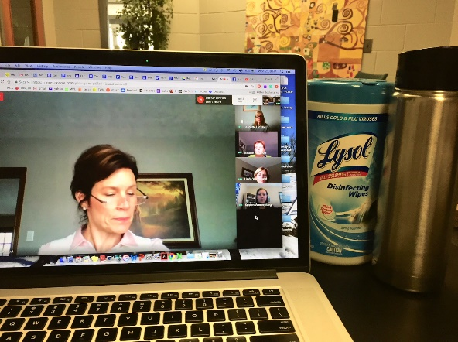
Remote meetings: Your teachers have been hard at work! Here is Mrs. Racicot on Wednesday morning leading the staff during devotional time while we had our second virtual staff meeting. Note that Mrs. Verbeek's desk is well equipped with coffee and disinfecting supplies. We have become very good at using GOOGLE MEET! If you look carefully, you will see a few more teachers in the meeting. Question: Who are they? Send me your guesses (principal@woodstockchristian.ca). You will have the opportunity to meet with classmates and your teacher through Google Meet or Zoom or other programs. Be patient with yourself and others this week as we learn how to navigate these new ways of being together.
Connected learning @ WCS: We have assembled what we hope will be a “one-stop” location in which you can find your child(ren)’s assignments, find links to connect with classes for MEET times, reading sites, and other information that your teacher posts. Check it out at https://sites.google.com/woodstockchristian.ca/connectedlearning/home
This google site was just constructed and is still in the development stage. There will be changes and adaptations as we move through the next few weeks.

Sonbeams program @ WCS is cancelled for the duration of the building closure. For parents who have registered their children in Sonbeams. Please contact the office if you have any questions.

Scheduling: Classroom teachers have shared these times with you in their communications, and here they are, all in one place. These are subject to change and we will publish the changes as they occur. Here is our preliminary schedule for online Google Meet times (middle column) per classroom, and ‘office hours’ during which you or students can connect with your teacher(s) to ask any questions, or to have a conversation about learning.
Grade/Teacher | “Meet” times to last no more than 15 minutes | “Office hours” outside of “Meet” time.
JK - L.Westerveld | 9:00 a.m. Tues, Wed, Fri | Open Tues, Wed, Fri
SK - V.Body | 9:15 a.m. Tues, Wed, Fri | 9-10/1-2 Tues, Wed, Fri
SK - K.Poort | 9:30 a.m. Tues, Wed, Fri | 9-11 Tues, Wed, Fri
1 - K. VanderPloeg | 10:00 a.m. | 9:00 - 10:00 & 1-2
2 - M. Horinga | 1:00 p.m. | 1-3
3 - G. Hiemstra | 10:15 a.m. | 10:30 to 12:30
4 - N. VanAndel | 10:30 a.m. | 10:45 to 12:45
4 - J. Hickey | 10:45 a.m. | 11:00 - 1:00
5 - A. Hiemstra | 8:30 a.m. | 9:00-3:00
6 - J. Bigham | 8:45 a.m. | 9:00-3:00
7 - L. Racicot | 11:45 a.m., 2:30 | 9:00-3:00
8 - T. Schaafsma | 12:00 p.m., 2:00 | 9:00-3:00
Dates to remember:
Thursday March 26- POSTPONED: K is for Kg (also Apr 2,9,16)
Tuesday March 31- CANCELLED: Rotary Music Festival 10:45 Jr Choir, 11:05 Sr Choir
Thursday April 2- POSTPONED: Grades 4-8 LCH drama
Saturday April 4- CANCELLED: SPRINGFEST
Wednesday April 8- TO BE DETERMINED: Possibly another format?? Good Friday / Easter chapel hosted by Grade 6
Friday April 10/Monday April 13- Good Friday / Easter Monday
Tuesday April 14- CANCELLED: Battle of the Books
Wednesday April 15- POSTPONED: Volunteer Appreciation Day, Prayer group, Staff PLC session
April 19-25 POSTPONED: Christian Education Week, 21st: Family open house/picnic & artwalk, 22nd: Grandfriends day,
Friday April 24- CANCELLED: Bluewater PD Day in Strathroy
Wednesday April 29- POSTPONED: CELEBRATION OF LEARNING

Student Support - Mrs. Bulthuis: Welcome back to school! Praying you are all well and adjusting to new routines and schedules. Despite all the uncertainty in the world, we can take comfort in a God whose love for us never changes. We are very excited to be moving our Student Support Services program online. Phase one is launching our Barton and grades 1-3 literacy support programs which will be followed next week by math programming. Look for an email from Mrs. Bulthuis which will outline how your child can continue to receive support from the comfort of your own home. Please feel free to contact me at t.bulthuis@woodstockchristian.ca with any questions or concerns.

JK- Mrs. Westerveld- Welcome back to term 3! I miss you all and am looking forward to seeing you online. Please look out for email and updates from me on seesaw.

SK- Mrs. Poort- I want to send a warm welcome and hugs to all parents at this time. I am happy to share with you that we will be resuming our education online right now. Each school day your students will have the opportunity to connect face to face with me. Please check your email and SeeSaw for messages.

SK- Miss Body- Welcome back to school. Our classroom is now on line and our learning is going to look different. I am excited to keep teaching and learning with you. Please read the email that will be sent with details about what to expect and look forward to. Praying for each of you as we navigate together.

Saturday: Happy Birthday Miss Body

Gr. 1- Mrs. VanderPloeg- I am praying for you and your family! During this time, I’m grateful for the reminder of our school theme: Overflowing with Thankfulness! I am thankful for YOU. Check your emails for an update on what learning in Grade One will look like for this week. I am here for you! We are in this together. God is on our side – and He is our Sustainer & Provider. I look forward to connecting with you this week.

Gr. 2- Mrs. Horinga- What a memorable March break this has been! I pray that you are all doing well and finding ways to see God amidst all that is going on in our world. I hope you are ready to begin our learning together tomorrow. Parents watch for a parent letter as well as the lessons for tomorrow via email.

Gr. 3- Mr. Hiemstra- Welcome back to learning though it will look very different for us for the next while. I will be using my teacher folder so you can check out the videos and docs in there. Please use this link as your starting place as it will provide other links to other “worlds” as we continue our learning in term three. Looking forward to “meet” with you regularly. We will make adjustments along this new path of learning. I will be praying for you regularly. Have a great week!

Gr. 4- Mrs. VanAndel- Welcome back to learning grade 4A. I hope you were all able to enjoy your March Break.
I am looking forward to this new adventure of “school” with you.
Please look for an email describing what will be happening in grade 4 this week.

Gr. 4- Mrs. Hickey- Welcome to a new week and an exciting new way of learning for term 3! Most of the news from now on will be on the WCS website for the online learning. Also keep checking your emails as I will keep in contact with you that way. Remember to keep a balanced day! No memory work or spelling test this week :)

Gr. 5- Mr. H- Thursday and Friday is all about exploring Google Classroom and doing a few small assignments relating to Language Arts. I am trying to keep it simple and manageable for you and your children!
If your family does not have many devices or you have several children that need a device, please contact Greg Hiemstra at g.hiemstra@woodstockchristian.ca and request to borrow a chromebook. Also, if you do not have a printer, please try to hook one up because it will allow for them to print the document and then fill it out in pencil, eliminating a lot of screen time.
Please read over the entire email I sent (Wednesday) and always feel free to email if you have any questions or concerns.

Gr. 6- Mrs. Bigham- Welcome back grade 6! This new way of doing school is definitely different but I think it is also going to be lots of fun! There will be things that are challenging, and require our perseverance but there are so many amazing opportunities for learning and growth for all of us.
On Thursday and Friday I will be helping the kids (& parents) get used to doing school at a distance. I know there are lots of questions and we will work through those together.
Know that you will be hearing from me daily in Google Classroom, through video and audio recordings. Also, I will be available to respond to questions through email throughout the day. We will also be doing a daily video "meet" with the whole class! Excited for this!!!

The students will be able to find information for their day in Google Classroom. They should check in once or twice a day.

Know that I am here to connect with you and help in any way I can. Please don't hesitate to reach out.

Gr. 7- Mrs. Racicot- Please go to Google Classroom for information

Gr. 8- Mr. Schaafsma- Welcome to Woodstock Christian School Remote Learning. As we continue to practice social distancing, we will be doing school from a distance as well. Please check Google Classroom for updates and to stay current with daily tasks and activities. We will also be using Google Meets to connect online a link will be provided via email to all of you. If you have any questions or concerns please email me and I will help you out. Blessings and stay healthy!

